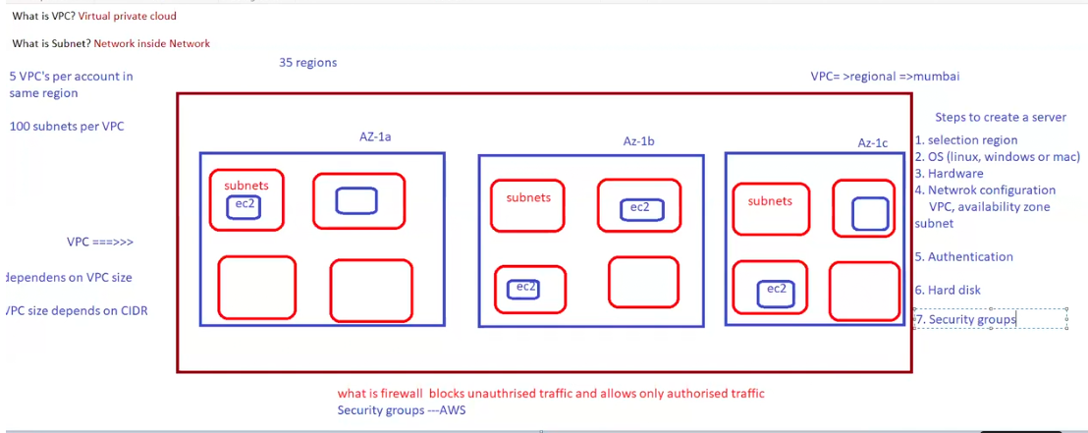

* VPC will support multiple subnets.
* Subnets will support multiple severs(ec2).
* Number of servers depends on CIDR range.
* Instant count depends on VPC size.
* VPC size depends on CIDR range.